Financial Control System (FCS)
Accounts Payable Project.
User Requirement Specification
Filing Reference : | ISS/FCS2/TS.1/1
Document Title : | User Requirement Specification
Version : | 1.0
Prepared By : | Low Siew Heng
Date Created : | Thursday, October 14, 1993
Approved By :
 |  | Howard Russon | Date
 |  | Project Manager
Authorised By :
 |  | Mike Fenton | Date
 |  | Project Director
 |  | Lian Wee Li | Date
 |  | Admin. Manager

Document Reference : ISS/FCS2/TS.1/1
©1993 ISS.  The information contained in this document is the property of ISS. The contents must not be reproduced, wholly or in part, for purposes other than for which it has been supplied, without the prior permission of ISS, or, if it has been furnished under contract to another party, as expressly authorised under that contract. ISS shall not be liable for any errors or omissions. | ISS
Version | Date | Author | Authorised by | Date
1.0 | 14/10/93 | Low Siew Heng

Financial Control System (FCS)
Accounts Payable Project.
User Requirement Specification
Distribution :
Name | Department | Organisation
Mike Fenton
Howard Russon
Lian Wee Li
Lim Swee Cheang
Low Siew Heng
Frank Jenkins
Er Geok Tin

Table of Contents.
1. INTRODUCTION. 1
1.1 Purpose. 1
1.2 Scope. 1
1.3 Audience. 1
1.4 Organisation. 2
1.5 Definition of Terms. 2
1.6 References. 2
2. OVERVIEW OF REQUIREMENTS. 2
2.1 System Interfaces. 2
2.2 System Functions. 3
2.3 User Characteristics. 3
2.4 General Constraints. 3
2.5 Assumptions and Dependencies. 3
3. FUNCTIONAL REQUIREMENTS. 4
3.1 Processing Requirements. 4
3.2 Inputs. 4
3.3 Outputs. 5
4. EXTERNAL INTERFACES. 5
4.1 Microcomputers. 5
4.2 Hardware Interfaces. 5
4.3 Software Interfaces. 6
5. QUALITY REQUIREMENTS. 6
5.1 Reliability. 6
5.2 Security. 6
5.3 Integrity. 6
6. ENVIRONMENT. 7
6.1 Hardware. 7
6.2 Software. 7
6.3 Methods. 7

Table of Contents.
7. DESIGN CONSTRAINTS. 7
8. CAPACITY. 7
9. GLOSSARY. 8
Appendix A : | Context Diagram.
Appendix B : | Matching List between Function Requirements and Context Diagram.

1. INTRODUCTION.
The Institute of Systems Science (ISS) requires the development of Financial Control System (FCS). This will involve the computerisation of the two major functions of the current manual system:
1. Invoice / Accounts Receivable; and
2. Accounts Payable.
The development is required to be undertaken in two stages. The first stage, to develop the Invoice/Accounts Receivable module has been completed. This project is required to undertake Stage 2 of the development, to develop the Accounts Payable module of the system. In addition, the project is required to undertake the enhancement of the existing module (Invoice / Accounts Receivable) to meet the new requirements.

1.1 Purpose.
The purpose of this document is to describe the user requirement for the Accounts Payable module of the Financial Control System (FCS). It also provides the basis for the production of the System Specification (ref ISS/FCS2/TS.2/1).

1.2 Scope.

1.2.1 Software.
This user requirement specification is solely concerned with the computerisation of the Accounts Payable system.

1.2.2 Documentation.
The following documents which are specified in the FCS Accounts Payable Project Plan, will be produced for both project team and users in this project.
• System Specification
• Programmer's Manual
• User's Manual

1.3 Audience.
The intended readers of this User Requirement Specification are:
1. The project team: This is to provide them on overview of the initial user requirements of the system to be developed.
2. Wee Li: She is required to review the specified requirements of the software in this document to ensure that all the user requirements have been addressed.

1.4 Organisation.
The overview of requirements for this project is specified in Section 2. The functional requirements are described in Section 3 and the external interfaces of this project are defined in Section 4. The quality requirements are given in Section 5 and the project's environment is identified in Section 6. Section 7 describes the design constraints and Section 8 specifies the capacity of the project. Finally, a glossary of terms used in this project are defined in Section 8.

1.5 Definition of Terms.
The following terms have special meanings within this document.
1. The word shall implies a mandatory requirement.
2. The word should implies a desirable requirement.
3. The word will implies a mandatory requirement outside the scope of this document.
4. The word may implies a desirable requirement outside the scope of this document.
5. A glossary of terms used for FCS Accounts Payable is given at the end of this document.

1.6 References.
To fully understand the background to this project, the reader should also be familiar with:
1. FCS Accounts Payable Project Plan, reference ISS/FCS2/MP.1/1, version 1.0, dated 9 July 1993.
2. FCS Accounts Payable Quality Plan, reference ISS/FCS2/MQ.1/1, version 1.0.

2. OVERVIEW OF REQUIREMENTS.

2.1 System Interfaces.
Currently, the supplier details are maintained by the Inventory Control System (ICS) and the Vote category details are computerised by the FCS Invoice/Accounts Receivable module. These two systems are to be interfaced with this system. In addition, the Purchasing system may be computerised and interfaced with this system. This system will enable users to check the status of a purchase requisition form that consists of a list of equipments/software to be purchased.
Apart from the above, a common Management Accounting System (MAS) proposed by NSTB is expected to be installed in 1995. Therefore the FCS system should be compatible as far as possible with MAS.

2.2 System Functions.
The following system functions are to be implemented in this system.
1. Production of the summary report of the Petty Cash flow.
2. Creation of purchase order records.
3. Processing of purchase orders to update the delivery order numbers.
4. Processing of purchase orders to update the invoice numbers for payment.
5. Creation of invoices (without purchase orders) received from creditors for payment.
6. Creation of claims and other expense payments transactions (without invoices). For these payments, the system shall automatically generate reference numbers.
7. Automatic updating the funds of a Vote category that is committed.
8. Updating the actual cash payment made by the Bursar's Office to keep track of the actual cash flow of each vote.

2.3 User Characteristics.
1. The main system users are Administrative Manager, Administrative staff and staff of Resource Centre who are all computer literate.
2. A user training session shall be provided for all users.

2.4 General Constraints.
Existing hardware and software resources shall be used for this project. No additional resources shall be provided.

2.5 Assumptions and Dependencies.
The Vote category database will be modified if necessary to provide the necessary interfaces with the FCS Accounts Payable module. All modifications will be completed before the FCS Accounts Payable module is subject to acceptance tests.

3. FUNCTIONAL REQUIREMENTS.
The Accounts Payable module of Financial Control System (FCS) performs the primary functions of accounts payable, as specified in the following subsections.

3.1 Processing Requirements.
1. The system shall provide facilities for the maintenance of the database for new Vote categories.
2. The system shall provide facilities for the maintenance of the database for new Cost Centres.
3. The system shall provide facilities for the maintenance of the database for Currency exchange rates.
4. The system shall provide facilities for the maintenance of the database for Suppliers/Creditors.
5. The system shall provide facilities for the maintenance of the database for Approved Professional Societies.
6. The system shall provide facilities for the funds transfer between Votes.
7. The system shall provide facilities for journal adjustment to the Votes.
8. The system shall provide facilities for the user to update the funds of the Votes based on the monthly statement of account received from NUS.
9. The system shall allow authorised users to cancel the purchased items once the items are confirmed to be unable to be supplied by the supplier.
10. The system shall be able to warn the user when the fund of a committed vote falls to a critically low level.
11. The system shall provide facilities for user to back up the database.

3.2 Inputs.
The following inputs shall be processed by the system.
1. Allows entry of purchase order records.
2. Allows users to update the delivery order number for a purchase order upon receiving the goods delivered by the supplier.
3. Allows users to update the invoice number for a purchase order upon receiving the invoice from supplier.
4. Allows entry of claims and other expenses payments.
5. Allows entry of petty cash transactions.
6. Allows entry of invoices (without purchase orders or delivery orders) received from suppliers/creditors.
7. Allows users to update the actual cash payment made by the Bursar's office.

3.3 Outputs.
The following outputs shall be produced by the system.
1. Petty Cash Transactions Log that shall replace the manual Petty Cash Book.
2. Cash Flow / Budget Tracking report.
3. Purchase order Transactions report.
4. Delivery order Transactions report.
5. Received Invoice Transactions report.
6. Claims / Expense Payment Transactions report.
7. Claims for Subscription to Professional Societies report.
8. Staff Travelling report.
9. Unsettled Payable Accounts report.
10. Currency Exchange Rate report.
11. Audit Trail report.
12. On-line Enquiry for the funds of Votes.

4. EXTERNAL INTERFACES.

4.1 Microcomputers.
The existing microcomputers installed at users' desks shall be used for this system.

4.2 Hardware Interfaces.
No special interfaces are currently planned. However, it may be considered necessary to attach the system to a scanner in future for scanning the purchase orders, delivery orders and invoices received from suppliers.

4.3 Software Interfaces.
1. FCS Accounts Payable module shall interface with the supplier details in Inventory Control System (ICS). The format of the supplier data is as follows:
SUPPLIER.
(Supplier-N, Supplier-M, Supplier-Addr1, Supplier-Addr2, Supplier-Addr3, Supplier-Tel, Supplier-Ext, Supplier-Fax, Supplier-Tlx).
2. The Vote category database of the FCS Account Receivable module will be modified in the following formats in order to interface with this system.
Vote.
(Vote-N, Vote-AC, Vote-M, Vote-Type)
VoteFunds.
(Vote-N, Vote-AC, Vote-Fin-Year, Vote-Budget-A, Vote-BF-Bal-A, Vote-CF-Bal-A, Vote-Commit-A, Vote-Payment-A, Vote-Recd-A, Vote-Adj-A, Vote-Exch-Diff-A)

5. QUALITY REQUIREMENTS.

5.1 Reliability.
FCS Accounts Payable module shall be available on every normal working day.

5.2 Security.
1. FCS Accounts Payable module shall only be available to users authorised by the Administrative Manager.
2. Access to the various functions shall be restricted according to the type of user.

5.3 Integrity.
All deleted transactions shall be traceable to the person who deletes the information.

6. ENVIRONMENT.

6.1 Hardware.
The system should run on the existing Novell Netware environment and shall make use of the existing microcomputer installed at users' desks. In addition to this, the system shall make use of the SYBASE server currently installed on the SUN UNIX system for data storage.

6.2 Software.
The following software packages shall be used for the project team to develop the system.
1. Microsoft VISUAL BASIC development software package;
2. Microsoft EXCEL spreadsheet package;
3. Borland C++ compiler and Microsoft WINDOWS SDK; and
4. SYBASE client libraries - NetLib and DBLib.

6.3 Methods.
ISS System Development Life Cycle (SDLC) and documentation standards shall be applied to this project.

7. DESIGN CONSTRAINTS.
1. The system shall be an MS Windows application.
2. An On-line help facility will be available.

8. CAPACITY.
1. Initially three users shall be connected to the system and all shall use the system concurrently.
2. Initially the system shall cater for:
(a) Maximum of 250 purchase orders per month.
(b) Maximum of 200 claim requests & other expenses payments per month.
(c) At least 250 Vote categories.

9. GLOSSARY.
Bursar's Office | A NUS department that deals with all the receivable and payable accounts.
Claim | The expense that is paid in advance by the staff and that is to be reimbursed to the staff.
Cost Centre | A department / section in ISS.
Creditor | A company or person that provides services / goods to ISS and to which ISS has to make a payment.
Delivery order | A form that is prepared by the supplier, and is received upon receiving the goods.
D.O. No. | An unique number that is shown in the delivery order received from the supplier.
Invoice | A statement is received from the supplier / creditor and used to send to Bursar's Office for payment.
Invoice No. | A unique number that is printed on the Invoice statement.
Petty cash | It is a small amount of cash in hand to be used for total payment below S$50.
Petty cash book | A book that is used to record the petty cash flow.
Purchase order | A form that is used to send to the supplier for confirmation of the items to be purchased.
P.O. No. | A unique number that is shown on the purchase order.
Purchase requisition form | The form that is used to send to ISS management for approval of equipments / software to be purchased.
Supplier | The company from which ISS purchases equipment / software.
Vote | It is a budgeted fund allocated to a department / section.

APPENDIX A : CONTEXT DIAGRAM
Context Diagram for FCS Accounts Payable Module
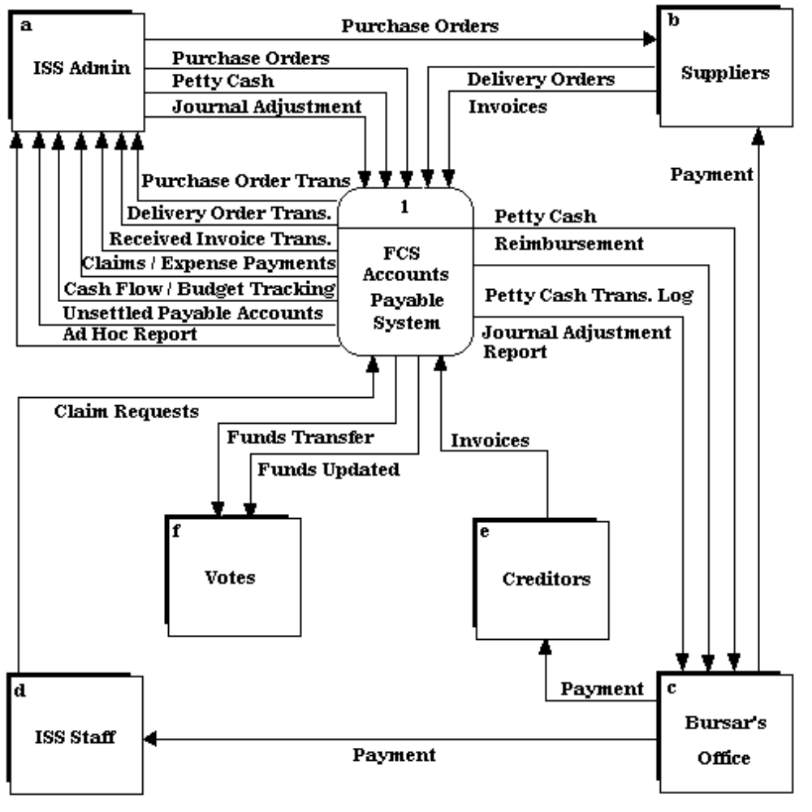

APPENDIX B :
Matching List between Function Requirements and Context Diagram
Ref. | Function Requirements | Context Diagram Data Flow
3.1 item 7 | The system shall povide facilities for the funds transfer between Votes. | Funds Transfer.
3.1 item 8 | The system shall provide facilities for journal adjustment to the Votes | Funds Updated.
3.1 item 9 | The system shall provide facilities for user to update the funds of the Votes based on the monthly statement of account recived from NUS. | Funds Updated.
3.2 item 1 | Allows entry of purchase order records. | Purchase Orders.
3.2 item 2 | Allows users to update the delivery order number for a purchase order upon receiving the goods delivered by the supplier. | Delivery Orders.
3.2 item 3 | Allows users to update the invoice number for a purchase order upon receiving the invoice from the supllier. | Invoices.
3.2 item 4 | Allows entry of claims and other expenses payments. | Claims / Expense Payment Transactions report.
3.2 item 5 | Allows entry of petty cash transactions. | Petty Cash.
3.2 item 6 | Allows entry of invoices (without purchase orders) received from creditors. | Invoices.

Ref. | Function Requirements | Context Diagram Data Flow
3.2 item 7 | Allows users to update the actual cash payment made by the Bursar's Office. | Petty Cash.
3.3 item 1 | Petty Cash Transactions Log that shall replace the manual Petty Cash Book. | Petty Cash Reimbursement.
3.3 item 2 | Cash Flow / Budget Tracking report. | Cash Flow / Budget Tracking.
3.3 item 3 | Purchase Order Transactions report. | Purchase Order Transactions.
3.3 item 4 | Delivery Order Transactions report. | Delivery Order Transactions.
3.3 item 5 | Received Invoice Transactions report. | Ad hoc reports.
3.3 item 6 | Claims / Expense Payment Transactions report. | Claims / Expense Payment Transactions report.
3.3 item 7 | Claims for Subscription to Professional Societies report. | Ad hoc reports.
3.3 item 8 | Staff Travelling report. | Ad hoc reports.
3.3 item 9 | Unsettled Payable Accounts report. | Unsettled Payable Accounts.
3.3 item 10 | Currency exchange rate report. | Ad hoc reports.
3.3 item 11 | Audit Trail report. | Ad hoc reports.
3.3 item 12 | On-line Enquiry for the funds of Votes. | Cash Flow / Budget Tracking.

Approval Record ISS/Forms/Approval

Project Name FCS Accounts Payable Project
Document Ref ISS/FCS2/TS.1/1
Approved by | Date
Authorised by | Date
The document authorisation appears on the title page.
The structure of the publication is logical.
The distribution list is correct.
The title page is signed.
Calculations appear reasonable, are neatly presented and have been checked.
Theory and formulae are correct and properly applied.
Illustrations are relevant, readable and logically placed.
There are no typographical errors.
Units are consistent throughout.
The security classification is correct.
There are no obvious omissions.
The document complies with the Client's requirements, however specified.
Responsibility is accepted for all opinions, conclusions and recommendations.
The document does not run counter to company policy.

